1-Intro
Test Case & Bug Report Writing (Introduction) - start at 0:01
this course has three videos
1-introduction
2-How to write a Test Case
3-How to write a bug report

2-Waterfall Model
Test Case & Bug Report Writing (Introduction) - start at 0:21
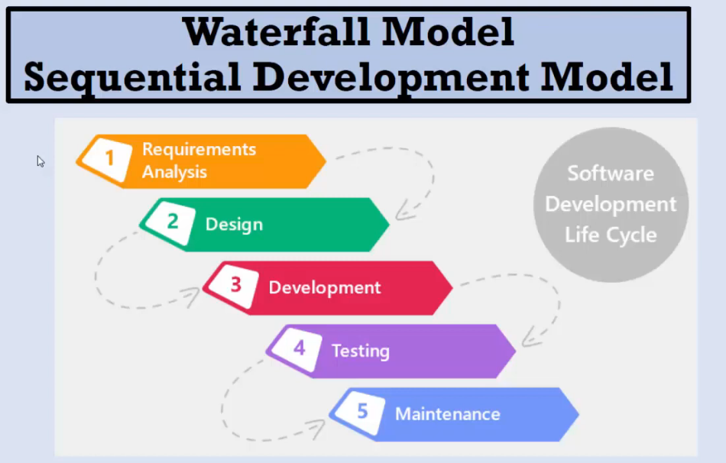

3-V-Model
Test Case & Bug Report Writing (Introduction) - start at 1:12
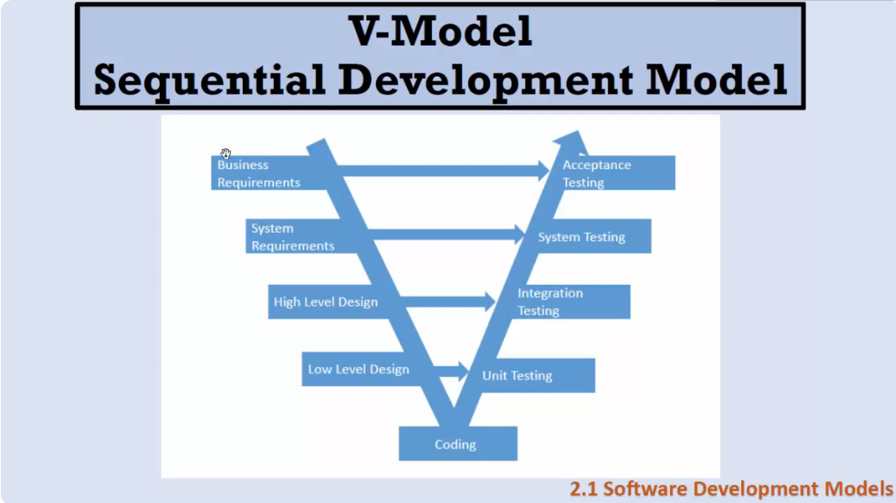

4-Fundamental Test Process
Test Case & Bug Report Writing (Introduction) - start at 2:06
